2026 TECH MAHINDRA TEST-1

Test Summary

* No. of Sections: 3
* No. of Questions: 47
* Total Duration: 90 min

Section 1 - VERBAL

Section Summary

* No. of Questions: 20
* Duration: 20 min

Additional Instructions:

None

Q1.

In the question below, a set of sentences is given which when properly sequenced, form a coherent paragraph. Arrange the sentences in the correct sequence from the answer options.

P. She saw a flickering light ahead, near the grove.

Q. The next instant Kitty was struck on the back of her head and fell unconscious.

R. A veiled figure with black hair and wearing a glowing white gown confronted her.

S. Curious, she drew closer.

(a)PQRS

(b)QSRP

(c)PSRQ

(d)QPSR

Q2.

**Fill in the blanks with the correct word:**

The children in the valley were ______ during the attack.

orphans

orphanage

orphaned

orphan

Q3.

**Fill in the blanks with the correct form of the verb that agrees with the subject in the following sentence:**

A good pair of black leather shoes____ a must have for every businessman.

are

is

have

has

Q4.

**Identify the error in the given sentence:**

Negative or withdrawn parenting is the major cause of increased levels of aggression and depresion in children.

depresion

negative

parenting

increased

Q5.

**The following question consists of a sentence that is either party or entirely underlined and may or may not have a grammatical error. Below each sentence are four versions of the underlined part of the sentence. Choose the option that correctly rephrases the underlined part of the given sentence Mark the answer as 'No Error if there is no error in the underlined part.**

As the primary function of newspapers was to communicate till the human race. what its members does, feel and think, journalism demands from its practitioners a high degree of intelligence, knowledge and experience.

was to communicate till the human race what it members does

Was to communicate to the humans race what its members do

Is to communicate to the human race what its members do

Is to communicate to the human race what its members does

No error

Q6.

**Fill in the blank with a suitable preposition.**

I saw Rahul _____ my friend's wedding.

over

on

in

at

Q7.

**Choose the correct option to complete the given sentence:**

All my students are well versed with the procedure. You can choose ______.

whichever you like.

whatever you like.

however you like

whomever you like.

Q8.

Rearrange the given phrases to form a complete sentence.

(A) unique and diverse

(B) bats, one of

(C) But misunderstood creatures

(D) the world's most

(E) are wonderful

B C A D E

B D A C E

A C D E B

B D A E C

Q9.

**Change the following sentence into direct speech.**

Jean said that she would be in Tokyo the following day.

Jean said "I will be in Tokyo tomorrow."

Jean said "She will be in Tokyo tomorrow."

Jean said "I will be in Tokyo."

Jean said "I would be in Tokyo."

Q10.

Fill in the blank using the correct verb.

In this office, politics ______ a sensitive issue.

is

are

am

were

Q11.

**Rearrange the given phrases to form a complete sentence.**

Note: The phrases numbered 1 and 6 are fixed.

1. The distinction on the basis

(A) within the family,

(B) of gender

(C) in the community and

(D) can be seen

6. even in public places.

B D A C

A D B C

B D C A

A C D B

Q12.

Fill in blanks with the suitable preposition:

Will you please write about Gandhiji ....... Mandela?

in front of

in spite of

instead of

into

Q13.

**Replace the underlined word in the following sentence with the most suitable option:**

Last night, the greengrocer was responding to the customer's unworthy allegations.

responded

would respond

can respond

should respond

Q14.

**Fill in the blank with the correct word.**

This industry has been _______ from the effects of competition.

eradicated

excluded

innovated

insulated

Q15.

**Rearrange the given phrases to form a complete sentence:**

Note: the phrases numbered 1 and 6 are fixed.

1. millions of students

(A) in different cities

(B) from all over India

(C) that are held

(D) appear in the examinations

6. by different recruiting organizations.

B D A C

D C A B

B D C A

A B C D

Q16.

**Fill in the blanks with the correct form of the verb that agrees with the subject in the following sentence:**

The players,as well as the manager _____ ashamed of the result.

is

does

are

would

Q17.

In the question below, a set of sentences is given which when properly sequenced, form a coherent paragraph. Arrange the sentences in the correct sequence from the answer options.

P. Julie hesitated and then stepped forward.

Q. The man's wife sat near him, but, without paying any regard to Julie's presence.

R. On entering the apartment, the first thing which struck Julie was the man himself.

S. He lay stretched out on his bed with his eyes closed.

QPRS

QRSP

SQRP

RSQP

Q18.

**Fill in the blanks with the correct form of the verb that agrees with the subject in the following sentence:**

Those women, along with a few college kids ______

runs an advertising firm

run an advertising firm

rans an advertising firm

runned an advertising firm

Q19.

The sentence given below has three parts, indicated by (A), (B) and (C). Read the sentence to find out whether there is any error and mark the part containing the error as the answer. If the sentence has no error, indicate the part (D), which stands for ‘No error’. (Ignore the error of punctuation, if any)

(A)My brother always likes/ (B) to travel by the air / (C) since he is a very busy man. / (D) No error.

A

B

C

D

Q20.

Choose the appropriate word to fill in the blank

We normally have lunch at about two in the afternoon ______ weekends.

in

on

by

during

Section 2 - Q&R

Section Summary

* No. of Questions: 15
* Duration: 20 min

Additional Instructions:

None

Q1.

**The question below consists of a question and two statements numbered A and B given below it. You have to decide whether the data provided in the statement(s) is/are sufficient to answer the question. Read both statements and give an answer.**

If X and Y are different positive numbers, is Z between X and Y?

(A) Z > 0

(B) Z < Y

if the question can be answered by using statement A alone but not by using B alone.

if the question can be answered by using statement B alone but not by using A alone.

if the question can be answered by using both the statements together but not by either statement.

if both the statements taken together are not sufficient and more information is required to solve the question

Q2.

If MATERIAL is coded as JXQBOFXI, how is JOY coded in that code?

MBT

GLV

LDU

BTK

Q3.

Muthu said, “This girl is the wife of the grandson of my mother who has only one son.” Who is Muthu to the girl?

Father

Grandfather

Husband

Father-in-law

Q4.

The daily income of two persons is in the ratio 4:7.If each receives an increment of 10 dollars in the daily income. The ratio is altered to 3:5.Find their respective daily services.

120 dollars and 210 dollars

80 dollars and 140 dollars

180 dollars and 315 dollars

200 dollars and 350 dollars

Q5.

The price of sugar is reduced by 25% but, in spite of the decrease, Aaron ends up increasing his expenditure on sugar by 20% What is the percentage increase in his monthly consumption of sugar?

60%

10%

33%

50%

Q6.

A man covered a certain distance at a certain speed. Had he moved the 3 km/h faster, he would have taken 40 minutes less. If he had moved 2 km/h slower, he would have taken 40 minutes more. The distance covered by him is:

35 km

40 km

45 km

50 km

Q7.

You are given three positions of dice then which face is opposite to the face with alphabet B?

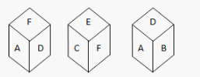

E

I

F

None of these

Q8.

**In the question below, a question and two statements numbered A and B are given. You have to decide whether the data provided in the statements are sufficient to answer the question. Read both statements and Give an answer**

At an alumni meet, a sum of Rs.500 was collected from each member and a sum of Rs.200 was collected from each non-member. How many members attended the meeting?

(A) The total collection was Rs.300,000.

(B) The number of members exceeded the number of non-members.

if statement (A) alone is sufficient to solve the question, but statement (B) alone is not.

if statement (B) alone is sufficient to solve the question, but statement (A) alone is not.

if neither statement (A) nor statement (B) is individually sufficient to solve the question, but a combination of both is sufficient to solve the question.

if both the statements taken together are not sufficient and more information is required to solve the question.

Q9.

Here, there are two sets of figures. The figures on left hand side are problem figures marked by numbers 1,2,3,4 and 5 and on the right hand side are answer figures marked by alphabets a, b, c, d and e. A series is established if one of the five answer figures is placed in place of the sign? In the problem figures. The figure from answer figures which should replace the sign? in problem figures is your answer.

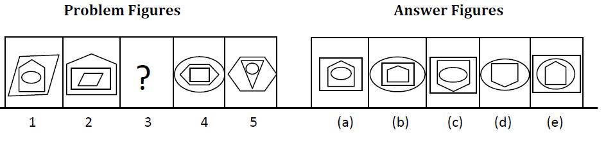

a

b

c

d

e

Q10.

Read the following information to answer the given questions:

1. Pepper Potts, Hulk, Ironman, Hawkeye, Thor, Loki and Black Widow are sitting in a circle.

2. Pepper Potts, Hulk, Ironman, Hawkeye, Loki and Black Widow are sitting at equal distances from each other.

3. Ironman is sitting two places right of Loki, who is sitting one place right of Hawkeye.(People seated equal distance only considered)

4. Pepper Potts forms an angle of 90° from Thor and an angle of 120° from Hulk.

5. Hulk is just opposite Black Widow and is sitting on the left of Thor.

The angle between Thor and Hulk in the clockwise direction is?

150°

180°

210°

None of these

Q11.

In the following question, there are four figures (i), (ii), (iii) and (iv) which constitute the problem set and answer figures marked 1, 2, 3 and 4 each consisting of two figures marked (i) and (iv) which constitute the answer set. Select the figure from the answer sets the contents of which best substitute (?) in the problem set such that figure (iii) is related to figure (iv) in the same way as figure (i) is related to figure (ii).

Q12.

In the following number series, one number is wrong. Find out the wrong number.

14, 30, 114, 564, 3120, 19590

30

114

564

3120

Q13.

A four-centimeter cube has been painted black on all its sides. It is cut into one-centimeter cubes. How many cubes will be there with at least two sides painted black?

8

24

32

64

Q14.

If John's income is 25% less than George's income, then by how much percent is George's income more than John's?

25%

30%

32.5%

33.33%

Q15.

**Choose the alternative that best completes the given comparison.**

ILLUMINATE : LIGHT

elucidate : clarity

mediate : memory

brainstorm : problem

facilitate : speed

Section 3 - TECHNICAL

Section Summary

* No. of Questions: 12
* Duration: 50 min

Additional Instructions:

None

Q1.

What incorporates data, architectural, interface, and procedural representations of the software?

design model

user’s model

mental image

system image

Q2.

If 2 classes derive one base class and redefine a function of the base class, overload some operators inside a class body. Among these two things of function and operator overloading, where is polymorphism used?

Function overloading only

Operator overloading

Both of these are using polymorphism

Either function overloading or operator overloading because polymorphism can be applied only once in a program

Q3.

How many instance initializers are in this code?

0

1

2

3

Q4.

What will the output of the following code be?

10 20

Compile time error

Segmentation Fault

Undefined Behavior

Q5.

Find the wrong statement about the Abstract class.

We can't create its objects

We can't create pointers to an abstract class

It contains at least one pure virtual function

we can create references to an abstract class

Q6.

What will be the output for the following code?

0

Value stored in arr[0]

00000

A hashcode or memory reference

Q7.

Identify the circumstances under which pre-emptive CPU scheduling is used:

(a) A process switches from Running state to Ready state

(b) A process switches from the Waiting state to a Ready state

(c) A process completes its execution

(d) A process switches from a Ready to a Waiting state

Choose the correct option:

(a) and (b) only

(a) and (d) only

(c) and (d) only

(a), (b), (c) only

Q8.

**Is the following statement True or False?**

Statement: If the condition in Step C updates the value in Box 3 instead of Box 2, then the flow chart will enter into an infinite loop.

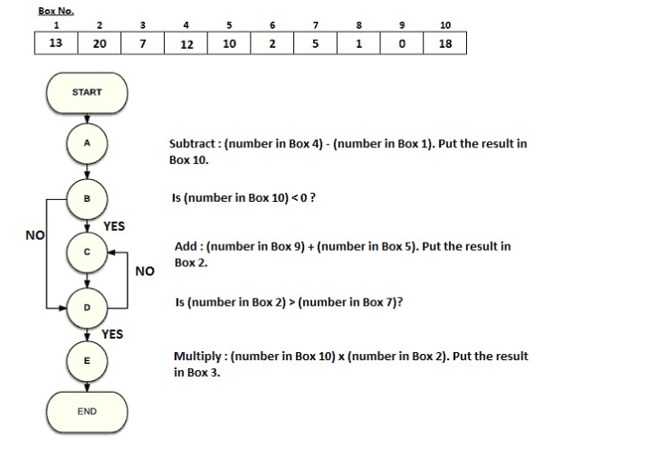

True

Zero

False

Cannot be determined

Q9.

What will be the output of the following program?

5

10

0

1

Q10.

Match List-I and List-II:

Choose the correct option from those given below:

(a)-(ii), (b)-(iv), (c)-(iii), (d)-(i)

(a)-(iv), (b)-(iii), (c)-(ii), (d)-(i)

(a)-(ii), (b)-(iv), (c)-(i), (d)-(iii)

(a)-(iv), (b)-(ii), (c)-(i), (d)-(iii)

Q11.

**Problem Statement**

Krishna is a census officer. He is involved in taking the survey about the village's total population, literacy percentage, men's population, and men's literacy percentage.

He wants to write a program to calculate the following:

1. Total population of men in the village
2. Total population of women in the village
3. Total population of literates in the village
4. Total population of illiterates in the village
5. Total population of men literate in the village
6. Total population of women literates in the village
7. Total population of illiterate men in the village
8. Total population of illiterate women in the village

Assist him in the program.

Input Format

The first line of input consists of the total population of the village.

The second line consists of the percentage of literates out of the total population.

The third line consists of the percentage of men in the total population.

The fourth line consists of the percentage of men literate out of the total population.

Output Format

The output prints the men population, women population, literates, illiterates, men literates, women literates, men illiterates, and women illiterates in the village.

**Refer to the sample output for the exact text and format.**

Sample Input

100

45

60

25

Sample Output

Men population=60

Women population=40

Literates=45

Illiterates=55

Men literates=25

Women literates=20

Men illiterates=35

Women illiterates=20

Time Limit: - ms Memory Limit: - kb Code Size: - kb

Q12.

**Problem Statement**

Sujanna is working on a program that involves shifting elements in a square matrix. The matrix has dimensions NxN, where N is the size of the matrix. She is tasked with writing a program that takes a square matrix as input and shifts each row of the matrix by K positions to the right. The value of K is also provided as input.

However, there is a constraint: the value of K should not exceed the size of the matrix (N). If K is greater than N, the program should output "Shifting not possible."

Input Format

The first line contains a single integer value 'N', which is the size of the square matrix.

The next 'N' lines contain 'N' integers representing the elements of each row of the matrix separated by space.

The last line contains an integer 'K' representing the number of circular shifts to be performed on each row.

Output Format

The output displays the matrix after performing the shifting operation.

If the shifting is not possible due to K being greater than N, then the program should output "Shifting not possible."

**Refer to the sample output for the formatting specifications.**

Constraints

2 ≤ N ≤ 10

-100 ≤ Matrix elements ≤ 100

2 ≤ K ≤ 10

Sample Input

4

1 2 3 4

5 6 7 8

9 5 1 2

45 6 8 2

2

Sample Output

3 4 1 2

7 8 5 6

1 2 9 5

8 2 45 6

Sample Input

3

1 2 3

4 5 6

7 8 9

4

Sample Output

Shifting not possible

Time Limit: 10 ms Memory Limit: 256 kb Code Size: 1024 kb

Answer Key & Solution

Section 1 - VERBAL

Q1

(c)PSRQ

Solution

Sentences P and S are a pair: P tells us what she saw, while S builds up on it, and tells us what she did on seeing it. Options A and B are eliminated. Sentences R and Q are also a pair: R tells us the strange figure she saw, and Q follows by what happened to her once she saw it. Option D is eliminated.

Hence, PSRQ is the right answer.

Q2

orphaned

Solution

No Solution

Q3

is

Solution

No Solution

Q4

depression

Solution

The spelling for depression is wrong in the given sentence.

Q5

was to communicate till the human race what it members does

Solution

No Solution

Q6

at

Solution

When you mean the exact place at is the appropriate preposition. 'in' is used in general sense.

Answer - at

Q7

whomever you like.

Solution

Whomever is an object pronoun and works like the pronouns him, her, and them. Hence, it is the suitable one amongst the options.

Answer - whomever you like

Q8

B D A C E

Solution

Coherent order - (B) bats, one of (D) the world's most (A) unique and diverse (C) But misunderstood creatures (E) are wonderful.

Answer - BDACE

Q9

Jean said "I will be in Tokyo tomorrow."

Solution

No Solution

Q10

is

Solution

politics - singular noun

Answer - is

Q11

B D C A

Solution

No Solution

Q12

instead of

Solution

The sentence is suggesting the idea to write about Gandhiji as a substitute or alternative to Mandela. So, 'instead of' is the right choice.

Q13

responded

Solution

Keyword - Last night

Tense to be used - Past tense

Answer - responded

Q14

insulated

Solution

**Insulated :**

This means to protect or shield from external influences. In the context of the sentence, it suggests that the industry has been safeguarded or buffered from the negative impacts of competition, which is the intended meaning.

Q15

B D C A

Solution

No Solution

Q16

are

Solution

The players is plural, hence the verb "are" is correct.

Q17

QRSP

Solution

R begins the passage by telling us what Julie saw as soon as she entered the apartment. S builds further on the man mentioned in R.

Q throws light on the other occupants on the room. P concludes by telling us Julie's response.

RSQP is the final arrangement.

Q18

run an advertising firm

Solution

the keyword "along with" indicates, subject "those women" is prioritized over the subject "college kids".

Since, women is plural, the verb must be 'run'.

Q19

B

Solution

Travelling by aeroplane is called as 'travelling by air,' so 'the' should not be there in B.

Q20

on

Solution

The preposition On is used for specific the time or date . Here it is on weekends (specific date)

Section 2 - Q&R

Q1

if both the statements taken together are not sufficient and more information is required to solve the question

Solution

Statement (A) it follows that Z is positive but not that Z is between X and Y.

Statement (B) alone is also not sufficient, because it is not known whether or not X < Z. Since the value of X is not known.

So, we need more data to solve the question.

Q2

GLV

Solution

Therefore, “JOY” is coded as “GLV” in the coded language.

Q3

Father-in-law

Solution

Mother’s grandson is my Son;

Son’s wife is my Daughter–in–law.

From the above, we conclude that Muthu is the Father-in-law of the girl.

Q4

80 dollars and 140 dollars

Solution

The daily income is in the ratio of 4:7.

Let the daily salary of the first person is 4z and the second person is 7z.

Each person receives an increment of $10 in the daily income. the ratio is altered to 3:5

$\frac{4z+10}{7z+10}=\frac{3}{5}$

From this z=$20

The salary of first person is 4z=4*20 =$80

The salary of first person is 7z=7*20 =$140

Q5

60%

Solution

The price of sugar is reduced by 25% but, in spite of the decrease, Aaron ends up increasing his expenditure on sugar by 20% What is the percentage increase in his monthly consumption of sugar?

60%

10%

33%

50%

Q6

40 km

Solution

x/y - x/y+3 = 40/60

x(y+3)-xy / y(y+3) = 2/3

3x / y(y+3) = 2/3

By Solving this, We get 2 x 12 x 15 =9X

X = 40 km/hr

Q7

F

Solution

From figures (i) and (ii), we can conclude that the alphabets C, D, A and E lie adjacent to the alphabet F. So, the alphabet B lies opposite F and conversely F lies opposite B.

Q8

if both the statements taken together are not sufficient and more information is required to solve the question.

Solution

Let the total number of members = x.

Let the total number of non-members = y

Total collection = 500x + 200y.

From statement (A), 500x + 200y = 300000. This is a linear equation of 2 variables, So, this statement alone is not sufficient.

From statement (B): x > y, which is insufficient.

Both statements together are also not sufficient.

Q9

e

Solution

The outermost symbol should be the innermost in the next figure. The second symbol should be the outermost symbol in the next figure.

So, in fig 3, the innermost should be the pentagon and rectangle should be the outermost. Fig e matches these conditions

Q10

None of these

Solution

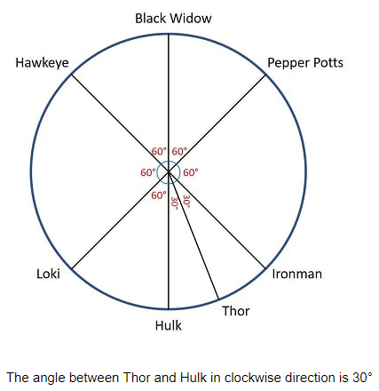

Q11

Solution

 Both the figures interchange their positions.

Q12

3120

Solution

The number series should be 3140 in the place of 3120.

The series is

(14 + 1^3) × 2,

(30 + 2^3) × 3,

(114 + 3^3) × 4,

(564 + 4^3) × 5 =3140 (In series it is given as 3120 which is the wrong term.)

Q13

32

Solution

Cubes with atleast 2 sides painted = Cubes with 2 sides painted + Cubes with 3 sides painted

= 12 x (n - 2) + 8

= 12 x (4 - 2) + 8

= 32

Q14

33.33%

Solution

When, a value increases by 1/x in terms of percentage,

Then the percentage decrease will be (1/x+1)

Since, the decrease here is 25%, (i.e., 1/4), the increase should be 1/3

i.e., George's income is 33.33% (1/3) more than John's

Q15

elucidate : clarity

Solution

illuminate means to make lighter or brighter.

elucidate means to make clear and comprehensible. Hence the answer.

Section 3 - TECHNICAL

Q1

design model

Solution

No Solution

Q2

Both of these are using polymorphism

Solution

No Solution

Q3

2

Solution

The code contains two instance initializer blocks that execute before the constructor, while the static block runs when the class is loaded.

Q4

Compile time error

Solution

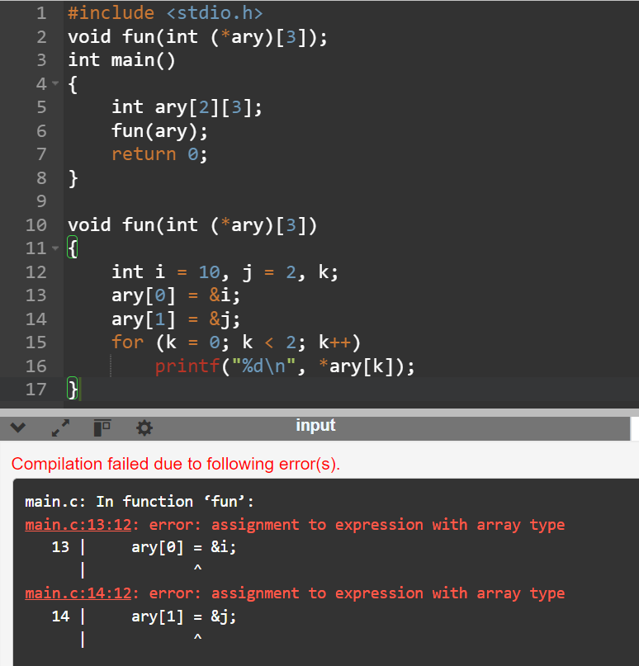

Q5

We can't create pointers to an abstract class

Solution

No Solution

Q6

A hashcode or memory reference

Solution

No Solution

Q7

(a) and (b) only

Solution

No Solution

Q8

False

Solution

even if Box 3 is updated instead of Box 2 in instruction C,

In instruction D, Number in Box 2 is compared with Box 7,

and the value is anyway greater, so the result is YES there and thus exiting and finishing the loop.

Q9

10

Solution

No Solution

Q10

(a)-(ii), (b)-(iv), (c)-(i), (d)-(iii)

Solution

No Solution

Q11

Solution

#include<stdio.h>

int main()

{

int totpop=0,menper=0,litper=0,mlitper=0,litpop=0;

scanf("%d%d%d%d",&totpop,&litper,&menper,&mlitper);

litpop=totpop*litper/100;

printf("Men population=%d\nWomen population=%d\nLiterates=%d\nIlliterates=%d\nMen literates=%d\nWomen literates=%d\nMen illiterates=%d\nWomen illiterates=%d",(totpop*menper/100),totpop-(totpop*menper/100),litpop,totpop-litpop,(totpop*mlitper/100),litpop-(totpop*mlitper/100),(totpop*menper/100)-(totpop*mlitper/100),(totpop-(totpop*menper/100))-(litpop-(totpop*mlitper/100)));

}

Q12

Sample Input

3

1 2 3

4 5 6

7 8 9

4

Sample Output

Shifting not possible

12Q

#include <iostream>

using namespace std;

int main()

{

int n,k;

cin>>n;

int mat[n][n];

for(int i = 0;i<n;i++)

for(int j = 0;j<n;j++)

cin>>mat[i][j];

cin>>k;

if (k > n) {

cout << "Shifting not possible";

return 0;

}

int j = 0;

while (j < n) {

// Print elements from index k

for (int i = k; i < n; i++)

cout << mat[j][i] << " ";

// Print elements before index k

for (int i = 0; i < k; i++)

cout << mat[j][i] << " ";

cout << endl;

j++;

}

return 0;

}

Top of Form

Bottom of Form

Top of Form

Bottom of Form